
Holy Cross College

Semester 1 Examination 2019

Multiple Choice Booklet

Please place your student identification label in this box
Year 10 Science
(Adjusted)

Student Name
Student’s Teacher

Time allowed for this paper

Reading time before commencing work: 5 minutes
Working time for paper: 60 minutes

Materials required/recommended for this paper

To be provided by the supervisor

This Question/Answer Booklet
Data Sheet

To be provided by the candidate

Standard items: pens, pencils, eraser, correction fluid, ruler, highlighters.
Special items: non-programmable calculators satisfying the conditions set by the School Curriculum and Standards Authority for this course.

Important note to candidates

No other items may be taken into the examination room. It is your responsibility to ensure that you do not have any unauthorised notes or other items of a non-personal nature in the examination room. If you have any unauthorised material with you, hand it to the supervisor before reading any further.

SECTION 1 MULTIPLE CHOICE (20 marks)

Make a choice of answer and mark it with a cross on the answer sheet in the answer booklet.

1. Most stars are made almost entirely of:

(a) hydrogen and helium.
(b) sulphur and oxygen.
(c) hydrogen and potassium.
(d) helium and carbon dioxide.

2. Roughly, how long ago was the Big Bang?

(a) 14 billion years ago
(b) 10 trillion years ago
(c) 1 billion years ago
(d) 65 million years ago

3. The space between stars is filled with dust and gas called:

(a) nebulae.
(b) galaxies.
(c) constellations.
(d) supernovae.

4. What is a black hole?

(a) A rapidly spinning star that gives out neutrons.
(b) A dark invisible hole in space that is a wormhole into another parallel universe.
(c) A massive explosion that gives out huge amounts of light.
(d) The remains of a star that is so massive that light cannot escape from it.

5. A light year is defined as:

(a) the distance light travels from the closest star.
(b) the distance from Alpha Centauri to the sun.
(c) the distance of the Earth from the sun.
(d) the distance light travels in a year.

6. Speed is a measure of the rate:

(a) at which distance is covered.
(b) at which speed increases.
(c) of change in force.
(d) of change in acceleration.

7. Calculate the speed of a bus that travels between two traffic lights 145 metres apart in
20.0 seconds. (Hint: Use sp, d, t triangle.)

(a) 7.00 m/s
(b) 7.25 m/s
(c) 6.25 m/s
(d) 7.50 m/s

The following diagrams represent the marks made on four separate tapes by the timing device as the cart moves.
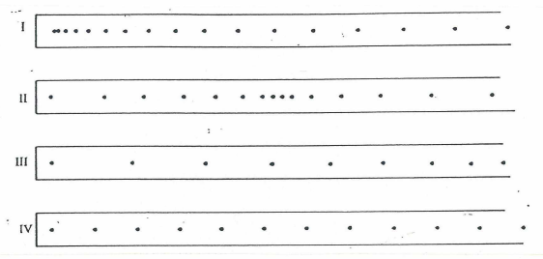

8. Which one of the diagrams best indicates that the cart was slowing down throughout the recorded time interval?

(a) I (b) II (c) III (d) IV

9. Which one of the diagrams best indicates that the cart started from rest and accelerated?

(a) I (b) II (c) III (d) IV

10. Which one of the diagrams best indicates that the cart was travelling at constant speed?

(a) I (b) II (c) III (d) IV

11. Which of the following are non-metals?

(a) sodium
(b) aluminium
(c) sulphur
(d) lithium

12. Which group of elements are called halogens?

(a) 1
(b) 2
(c) 17
(d) 18

13. A pure substance:

(a) is made of only 1 type of atom.
(b) has 2 or more elements chemical combined.
(c) is made of only 1 type of particle.
(d) is also known as a compound.

14. The element sodium is an example of:

(a) an alkali metal.
(b) an alkaline earth metal.
(c) a halogen.
(d) a noble gas.

15. A covalent bond will form between:

(a) 2 different metals.
(b) a metal and a non-metal.
(c) non-metals only.
(d) a pure metal.

16. Where is human DNA stored?

(a) In the cells of embryos but not adults.
(b) In the nucleus of each cell.
(c) In brain cells but not muscle cells.
(d) In the cytoplasm of each cell.

17. Which of the following base pairs is possible?

(a) A-C
(b) A-T
(c) T-G
(d) C-T

18. What are the two main roles of mitosis in the body?

(a) Growth
(b) Repair
(c) Digestion of food
(d) Sexual reproduction

19. The daughter cells produced by mitosis are:

(a) unable to divide again.
(b) genetically unique.
(c) genetically identical to the parent cell.
(d) genetically identical to each other.

20. How many chromosomes do humans have?

(a) 23
(b) 46
(c) 22
(d) 44

END OF SECTION 1

